
Client Background
GameNest is an E-commerce company specializing in gaming peripherals such as mice, headsets, monitors, PlayStation, and accessories. It was established in 2018 and quickly position itself as a trusted shop for gamers seeking quality and competitively priced products.
Business Objectives
As GameNest continues to expand, the team aims to strengthen data driven decision making and want to uncover Sales Trends, Product Performance, Regional Dynamics, and Marketing Channel Effectiveness.

Executive Summary
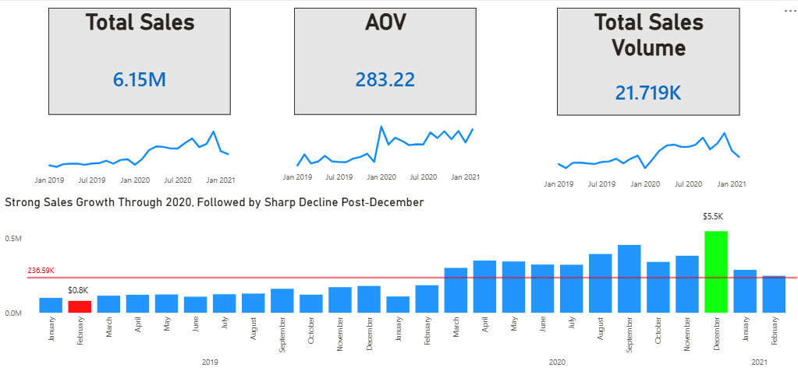
Sales Insights
- Sales Growth
- Overall Growth: Total sales reached an outstanding 6.15M with 21.7K orders. Remarkable increase of 204% in sales for 1 year but after a month, 47% decrease due to Holiday Event or Promotions.
- Peak Performance: December 2020 recorded the highest monthly sales ($5.5K), marking the culmination of two years of growth.
- Decline: After December 2020, sales dropped sharply, with early 2021 figures falling below the average sales (236.59K reference). Despite the fact that the Total Sales and Volume have been declined, the Average Order Value continue to show a steady upward trend, reflecting stronger demand for higher value products.
- Trend Analysis
- 2019: Modest beginnings, with February 2019 at only 0.8K.
- 2020: Consistent upward trajectory, fueled by increased demand for gaming peripherals due to the COVID seasons and indicating a global market trend.
- 2021: Clear downturn, indicating either market saturation, reduced consumer spending, or weaker marketing push.
- Seasonal Trends
- Holiday Season Impact: Q4 (especially December) consistently outperformed other months, confirming strong seasonality.
- Mid-Year Plateau: Sales between Q2–Q3 were relatively stable but lower, suggesting weaker demand outside promotional periods.
- Campaign Sensitivity: Spikes align with promotional events (e.g., holiday sales), showing reliance on seasonal campaigns.
- Recommendation
- Inventory & Supply Chain: Increase stock of high-demand products before Q4 to maximize holiday sales.
- Marketing Strategy: Launch mid-year campaigns (summer gaming bundles, back-to-school promotions) to reduce reliance on Q4 spikes.
- Product Focus: Identify which products and categories (headsets, monitors, device) drove December 2020’s peak and replicate success with new launches.
- Customer Retention: Introduce loyalty programs or subscription models to sustain engagement beyond seasonal peaks.

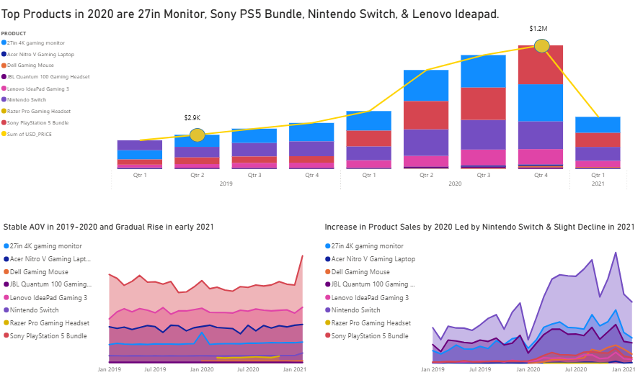
Product Performance

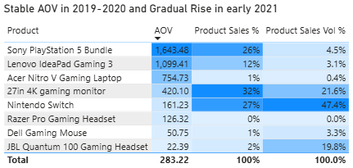
- Overall Findings
  - Sales Distribution: The product mix shows a strong concentration in a few high-performing items: 27in 4K Gaming Monitor and Nintendo Switch together account for 59% of total sales and 69% of total volume.
  - AOV Behavior: The Average Order Value (AOV) remained stable through 2019–2020 and began rising in early 2021, signaling a shift toward higher-value purchases.
  - Revenue Drivers: Premium products like the Sony PlayStation 5 Bundle and Lenovo IdeaPad Gaming 3 contributed significantly to revenue despite lower sales volume.

- Best Performing Products
- 27in 4K Gaming Monitor – Highest sales share (32%) and strong volume (22%). Affordable yet high-demand item for PC gamers.
- Nintendo Switch - Dominated volume (47%) and maintained solid sales share (27%). Excellent mass-market appeal.
- Sony PS5 Bundle - Premium product with highest AOV (1,643.48). Drove 26% of total sales despite only 4% volume.
- Underperforming Products
- Acer Nitro V Laptop - Low sales (1%) and negligible volume. Poor competitiveness in mid-range laptop segment.
- Razer Pro Gaming Headset – 0.003% sales and volume, likely outdated or poorly marketed.
- Dell Gaming Mouse - Low AOV and minimal contribution to revenue.
- JBL Quantum Headset - Decent volume (20%) but low AOV (22.39). High quantity, low profitability.
- Key Observations & Recommendation
- Diversify Product - Introduce mid-range laptops and accessories better value propositions.
- Inventory Strategy – Prioritize stock for the top performing products before holiday peaks and reduce low turnover accessories or products
- Marketing Optimization – Maintain strong Q4 campaigns, add recurring sales (Pay Day, Flash Deals, and Double-Date Sales) and align campaigns with local holidays and mega events (Back to school Promo, Black Friday, and mid-year sales).

Marketing Performance
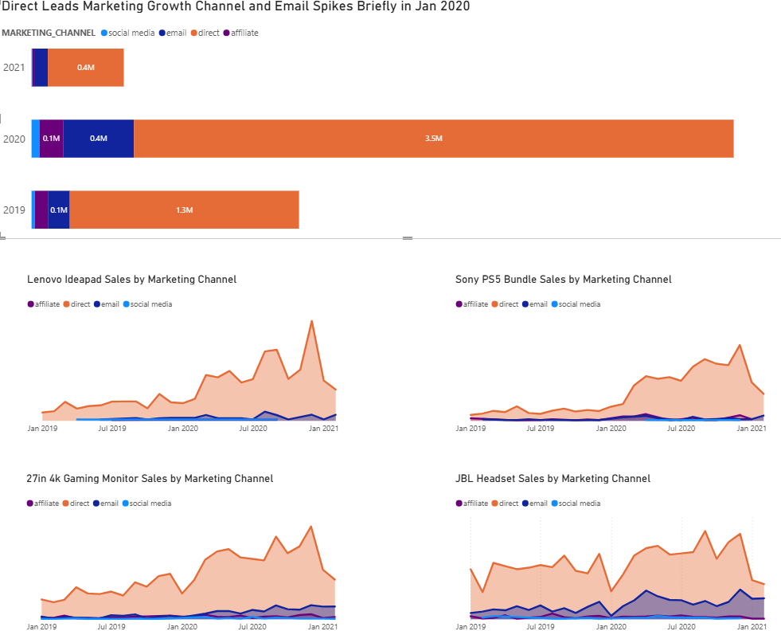
- Channel-Level Performance
- Direct Marketing
- Direct has been consistently the main driver of marketing channel sales, contributing to 80-85% of overall share across the years.
- The top products have a steady increase of performance on Channel indicating its consistency especially on Sony PS5 Bundle.
- Grew from 1.3M in 2019 to 3.5M in 2020 (169% increase).
- Email Marketing
- Noticeable spike in Jan 2020 (0.4M), outperforming social media and affiliate highlighting its potential growth
- JBL Headset and 27in 4k Gaming Monitor have a great performance on the channel compare to the other top products.
- Affiliate & Social Media Marketing
- The two marketing channels combine contribute for only <10% of overall performance
- Investigate further the promotions on the channel and cut off budget since their performance were relatively low for the timeline.
- Key Observation and Recommendation
- Diversify Channel Strategy
- Reduce dependency on Direct by scaling Email (automation, personalization) and revitalize social media (influencer partnerships, target ads).
- Product Specific Marketing
- Continue leveraging direct and boost Email Marketing for its potential growth with other products

